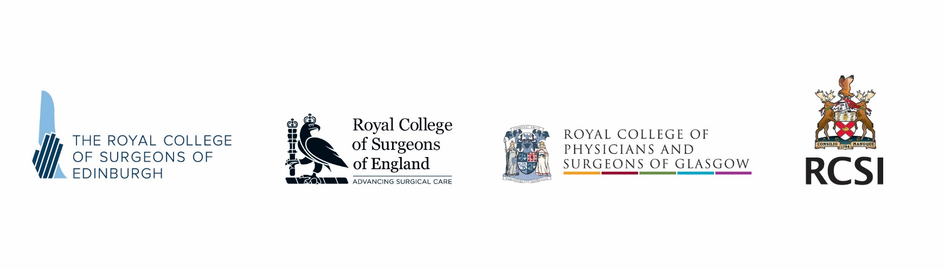
Intercollegiate Research Fellowship

Applications are sought from the four Surgical Royal Colleges for a new one-year Research Fellowship to be administered through the Intercollegiate Committee for Basic Surgical Examinations (ICBSE). Following the success and progress made by our first Intercollegiate Research Fellow (10 publications to date, a book chapter and a PhD), the four Surgical Colleges have agreed to fund and support a new fellowship to continue this important work.

The Surgical Royal Colleges jointly manage the MRCS and DO-HNS examinations through ICBSE. We are planning to continue several exciting research initiatives in relation to the development and MRCS outcomes in line with work being done by other Medical Royal Colleges.

The new appointee will continue work to further address the predictive validity of MRCS in surgical training and explore the reasons behind the differential attainment gaps observed for different groups of doctors. For example, why are female and Black Minority Ethnic trainees more likely to fail surgical postgraduate written exams compared to male, white doctors? This research will have wide benefit to surgery in general and UK training schemes. The projects will be supervised and lead to publications in peer-reviewed journals and the successful applicant would be encouraged to register for a higher degree (MD, MS or PhD). We have a fantastic nationally recognised research team with input from a Professor of Medical Education, statisticians, psychometricians and other experts.

The Fellowship will cover salary (at ST level), on-costs and some running expenses. As the role is a desirable educational development opportunity for the successful applicant no VAT will be applicable to the reimbursement of their salary.

Applicants must be fully registered with the GMC and ideally have passed both parts of the MRCS. Previous experience in research and/or education would be considered an advantage, though not essential.

How to apply

Applicants must send a full Curriculum Vitae and a supporting statement of no more than one side of A4 outlining why you want the role and why you are suitable to gayre@icbse.org.uk

- Closing date: Monday 19 August 2019

For an informal discussion about the research and fellowship, please contact the ICBSE Research Lead, Professor Peter Brennan (peter.brennan@porthosp.nhs.uk) who is leading and supervising our MRCS research.

